**Practical-2:** Figma design tools and applying properties

**Definition:** Develop 1 screen using the tools listed below: Blending Modes, Alignment, & Distribution, Shadow, Blur Effects, Fill, & Stroke, Text Properties & Styles.

**Solution:**

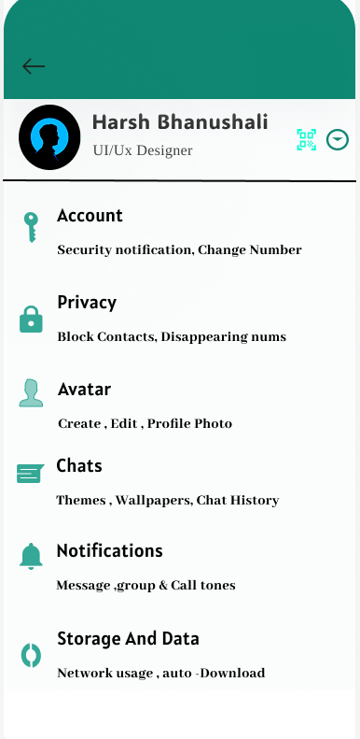

**Working:**

* First, open Figma. Add a new Figma design file.
* Rename a file as 133_Practical-1_GeometricShapes.
* In this design, the following tools are used for a particular operation:
* Export your design as a PNG file.

|  |  |  |
| --- | --- | --- |
| **Tools Name** | **Use** | **Properties** |
| Frame Tool (F) | The frame is used as a container for this mobile screen design. I created it first as my working canvas. | Width: 386px, Height: 791px  Corner Radius: 30px on top corners for a rounded screen look  Color fill: #128C7E (green header background) Blend mode: Pass Through |
| Rectangle Tool (R) | Used to draw the white background area below the green header. | Width: 386px, Height: (remaining height)  Color fill: #FFFFFF No stroke Rename as “Background Rectangle” |
| Ellipse Tool (O) | Used to create the circular profile photo placeholder under the header. | Diameter: 66px  Color fill: #000000 (or place an image fill) No stroke Rename as “Profile Picture” |
| Text Tool (T) | Used to add text elements like name, designation, and all list items. | Font: e.g. Poppins or Roboto  Font weight: Bold for headings, Regular for subtext  Font sizes: e.g. 18px for headings, 14px for subtext Color: #000000 |
| Line Tool (L) | Used to create the divider line below the profile section. | Width: 386px  Stroke weight: 1px  Color fill: #000000 Rename as “Divider Line” |
| Image/Icon Tool | Used for inserting icons like key, lock, avatar, chat, bell, and storage symbol beside each menu label. | Use icons from Figma Community or Material Icons. Size around 24px × 24px  Color fill: #128C7E Rename as per icon name, e.g. “Key Icon”, “Lock Icon,” etc. |
| Align Tool | Used to align icons and text in neat rows for each setting option. | Align left edges or vertically center. Shortcut: Shift + H or Shift + V |
| Auto Layout (Shift + A) | Used to keep each row (icon + text) together with proper spacing between them. | Horizontal layout Spacing between icon and text: 8px to 12px Vertical spacing between rows: 16px to 24px |
| Layer Rename | Helps keep all layers organized and easy to identify. | Examples: “Header Rectangle,” “Profile Name Text,” “Privacy Icon,” etc. |
| Export Tool | Used to save the final design as an image for submission. | Go to File → Export → JPG or PNG Choose desired resolution and quality |